**SimAgile Execution 2 Report - Team Based Response (60 Points)**

***Please use the following link to access SimAgile:*** [***http://agile.simproject.com/***](http://agile.simproject.com/)***. Complete a second execution from beginning to end and answer the questions that follow.***

***Important Note: if you receive an error while using SimAgile, please try rebooting your computer. If the problem isn’t fixed, please send an email to*** [***support@simulationpl.com***](mailto:support@simulationpl.com)***.***

**Sprint 1 - Week 1 and Week 2 (10 Points)**

**Product Backlog (one screen shot for sprint 1)**

* Paste a screen shot of your product backlog prior to starting sprint 1.

**Answer**

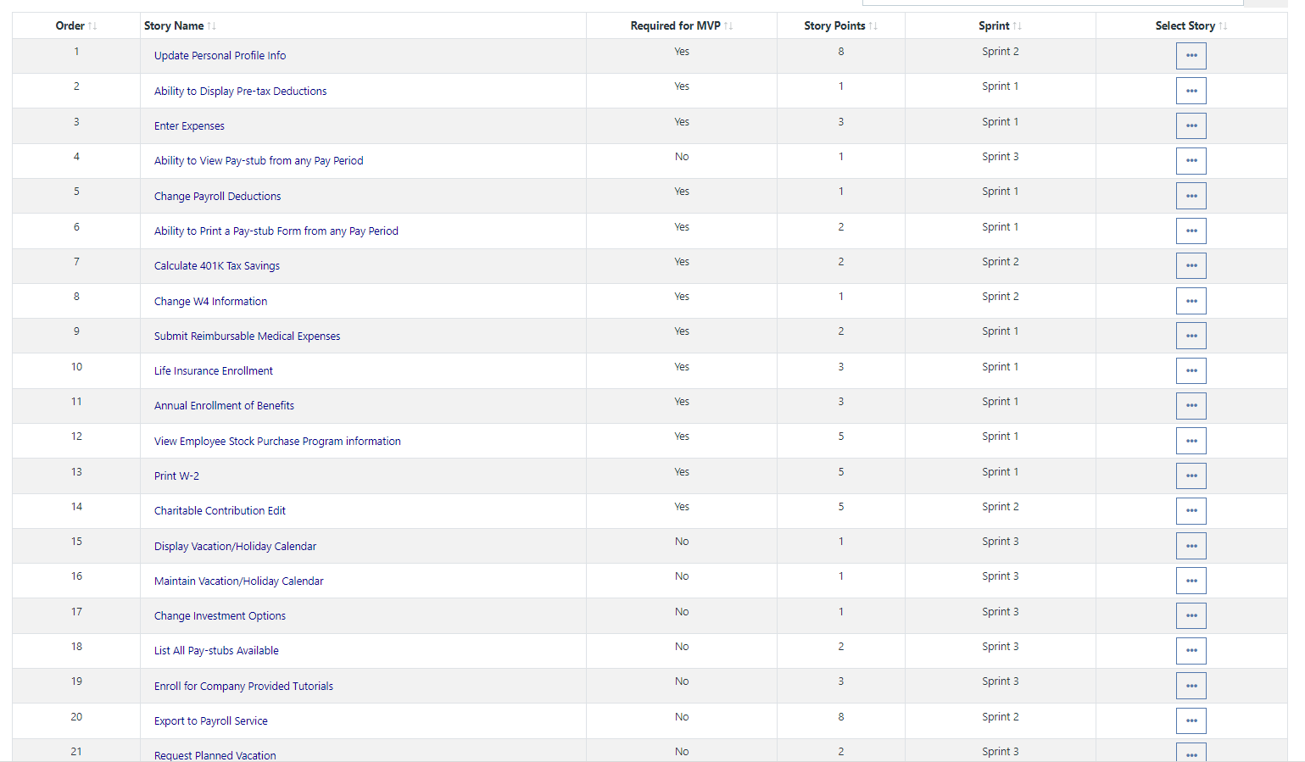

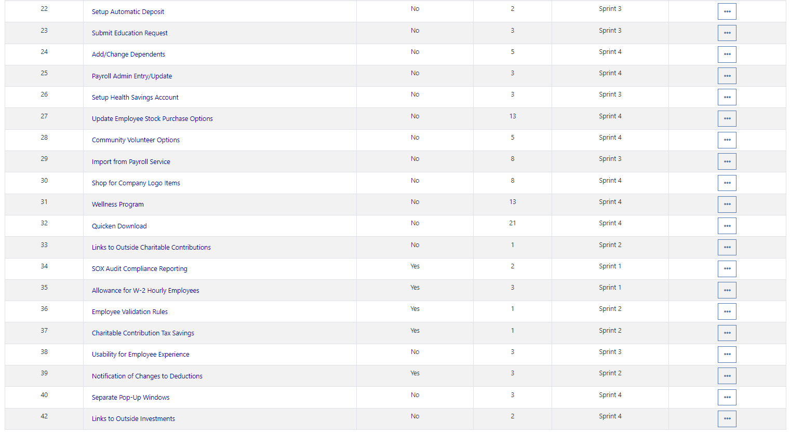

* Please explain what you did in grooming the user stories in your product backlog and your reasoning for these decisions.

**Answer**

**Scrum Board**

Scrum Board screen shot before sprint 1 has started

**Answer**

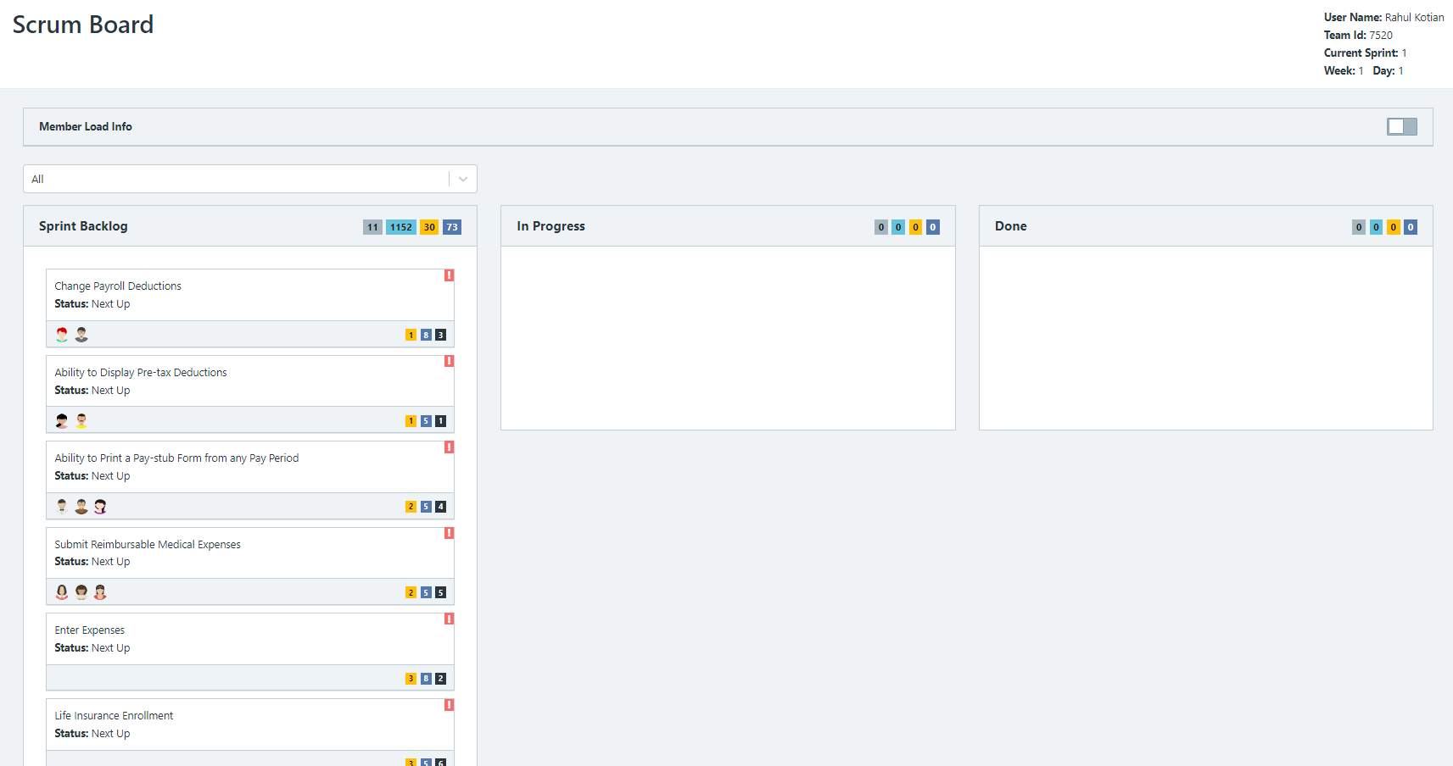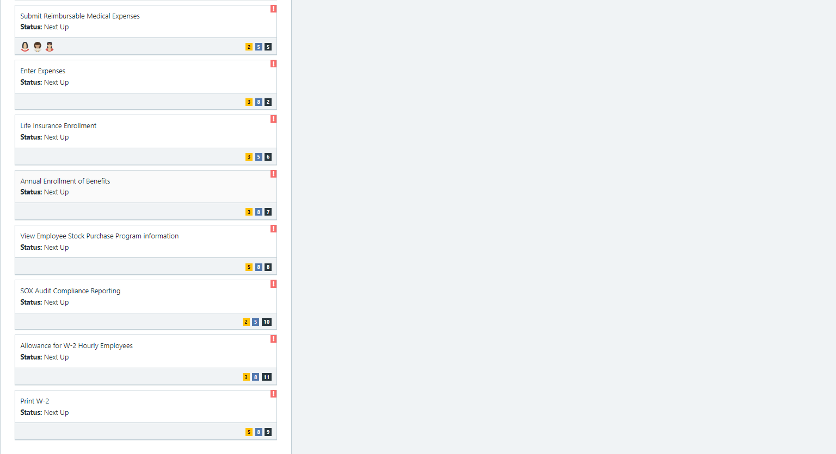

Scrum Board screen shot after 1st week of sprint 1

**Answer**

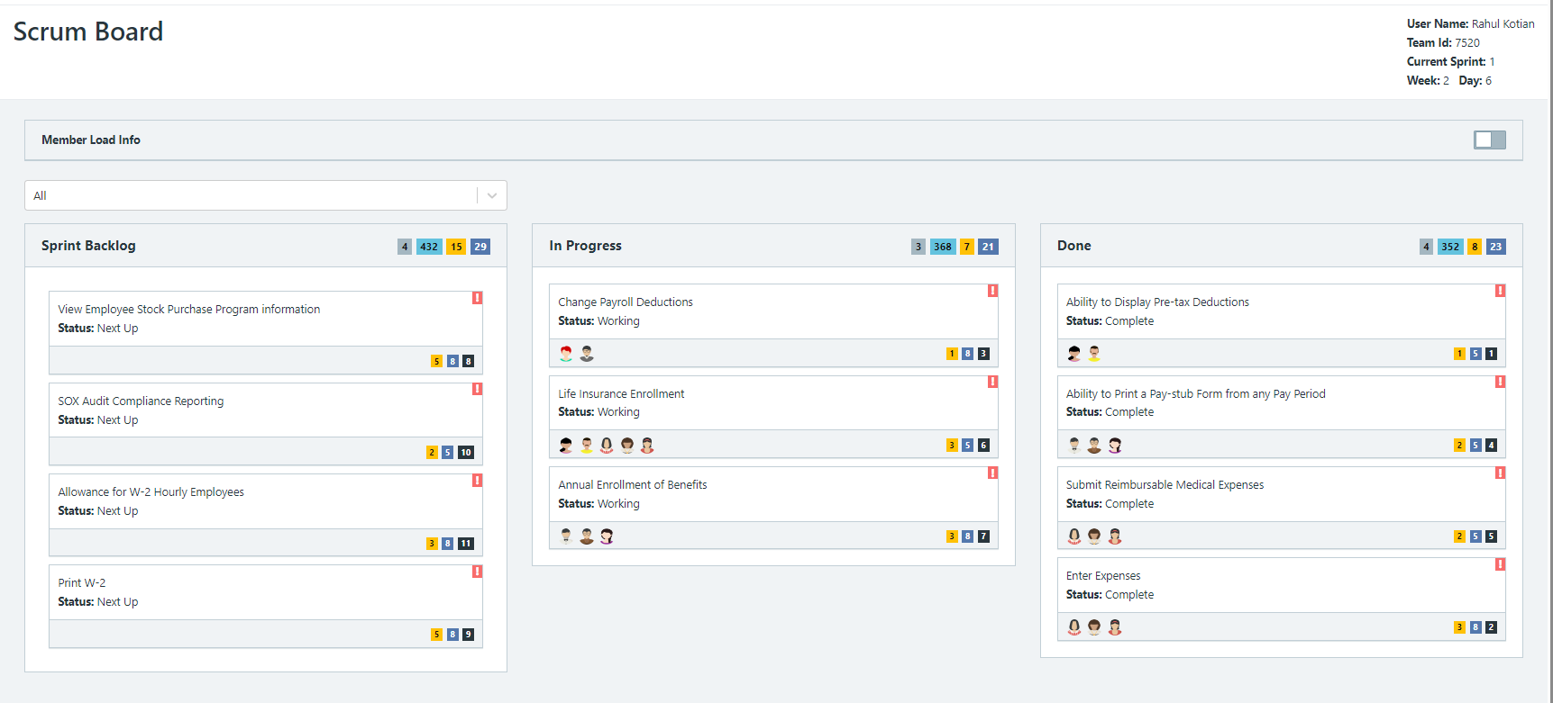

Scrum Board screen shot after 2nd week of sprint 1

**Answer**

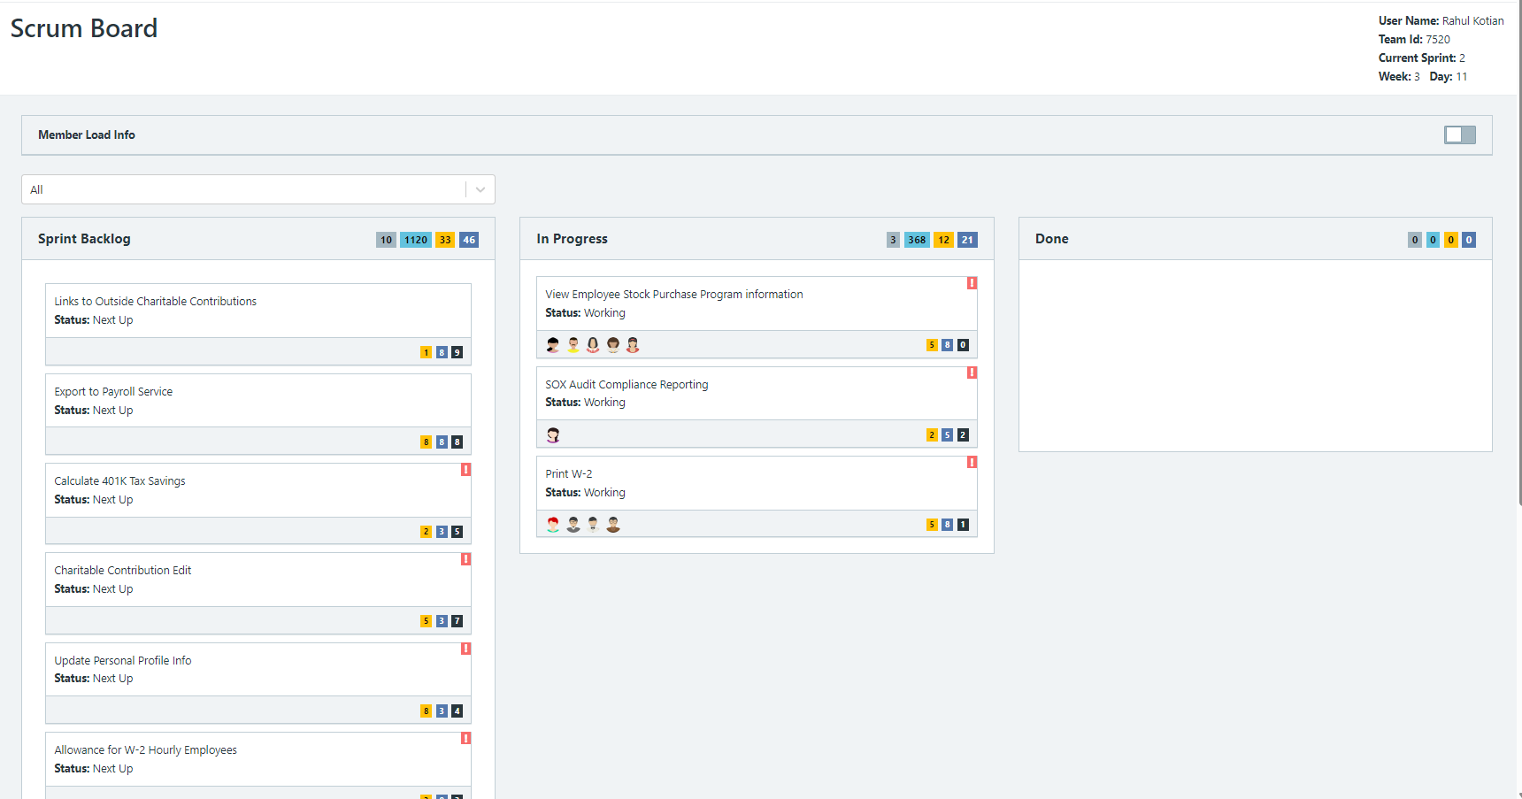

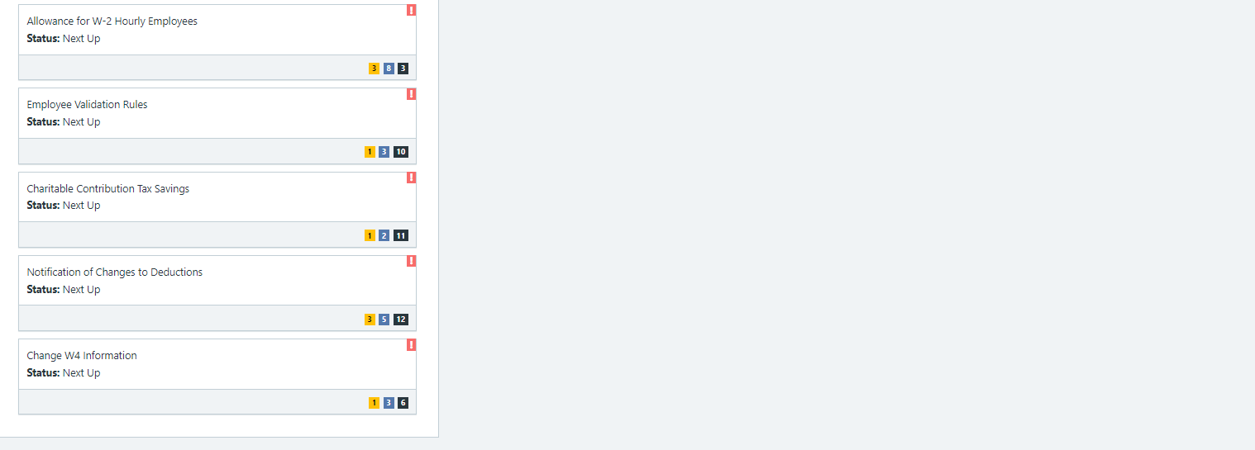

**Calendar**

Paste a screen shot of your calendar for sprint 1

**Answer**

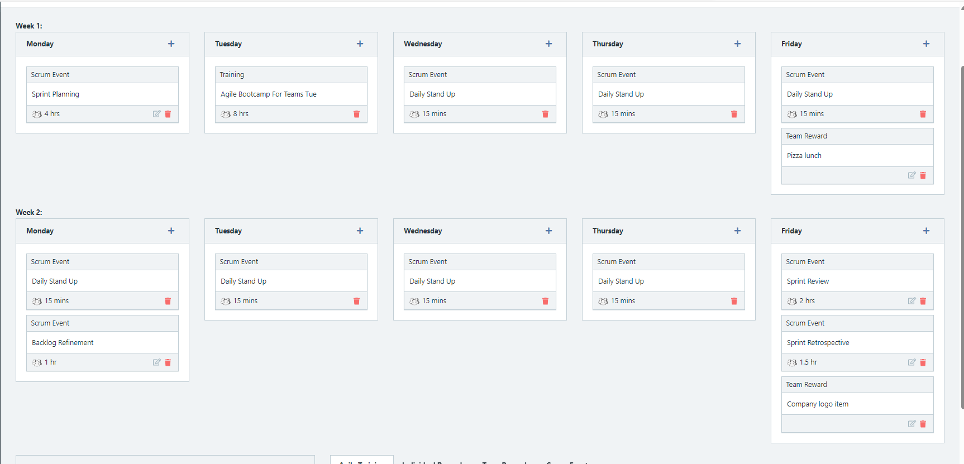

Explain the reason why you have scheduled the meetings listed shown on your calendar.

**Answer**

**Burn Down**

After competing sprint 1, paste a screen shot of the sprint 1 Burn Down Chart below.

**Answer**

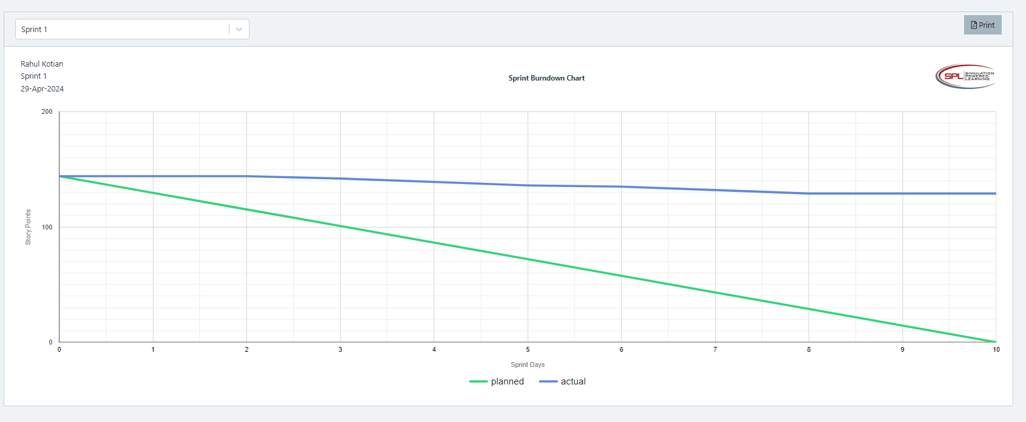

**Velocity Trend**

After competing sprint 1, paste the sprint 1 Velocity Chart below:

**Answer**

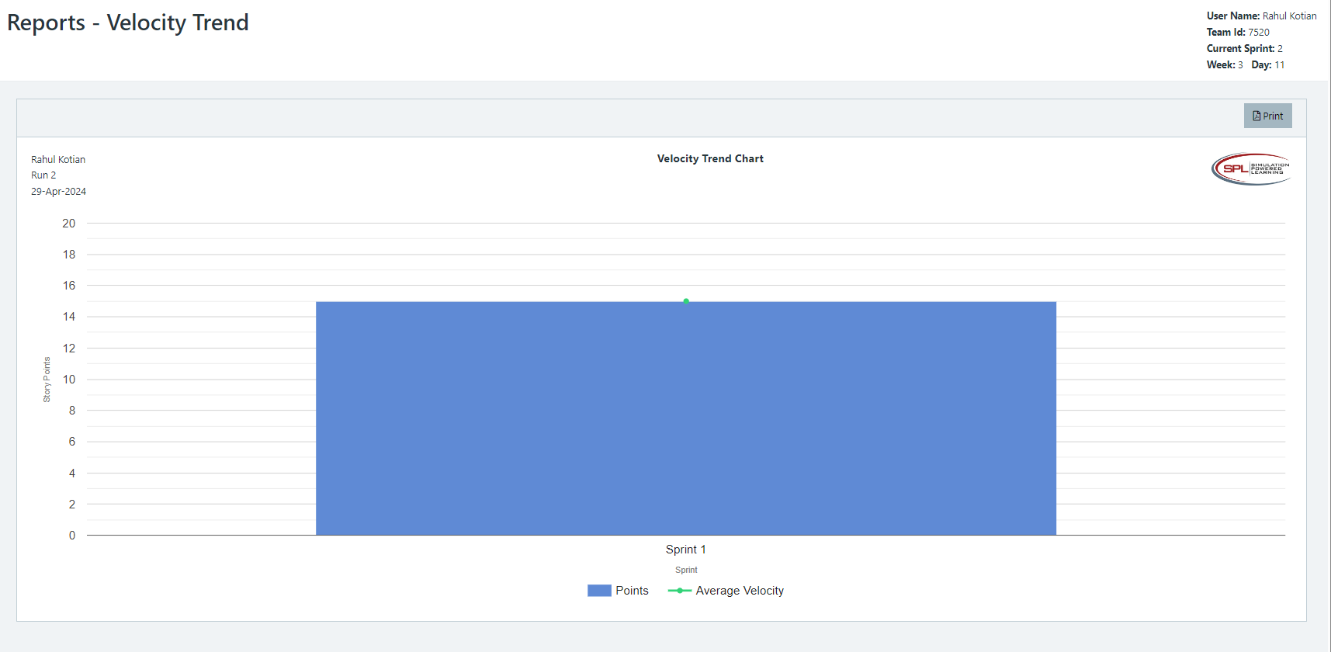

**Retrospective Meeting:**

How did you do in this Sprint?

**Answer**

What problems, if any, did you encounter as you were executing the sprint?

**Answer**

What changes, if any, are you are planning to make in the next sprint?

**Answer**

**Answer following questions based on this Sprint:**

What is the velocity (in story points) for the sprint?

**Answer 15**

What is the average velocity, minimum velocity, and maximum velocity (in story points) for the project across all sprints that have been completed so far?

**Answer**

Average velocity: 15

Minimum velocity: 15

, and maximum velocity: 15

Based on the current status of your project, do you believe that you will be able to complete the mandatory (or required) stories in the product backlog within the four sprints?  Explain your answer.

**Answer**

Based on the current status of your project, do you believe that you will be able to complete all stories in the product backlog within the four sprints planned? Explain your answer.

**Answer**

**Sprint 2 - Week 3 and Week 4 (10 points)**

**Product Backlog (one screen shot for the sprint)**

Paste the screen shot of your Product Backlog below.

**Answer**

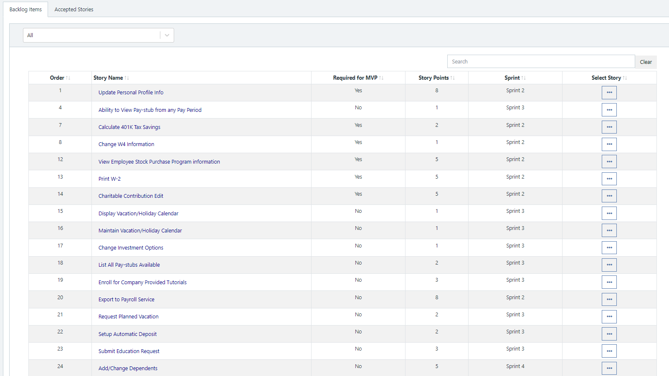

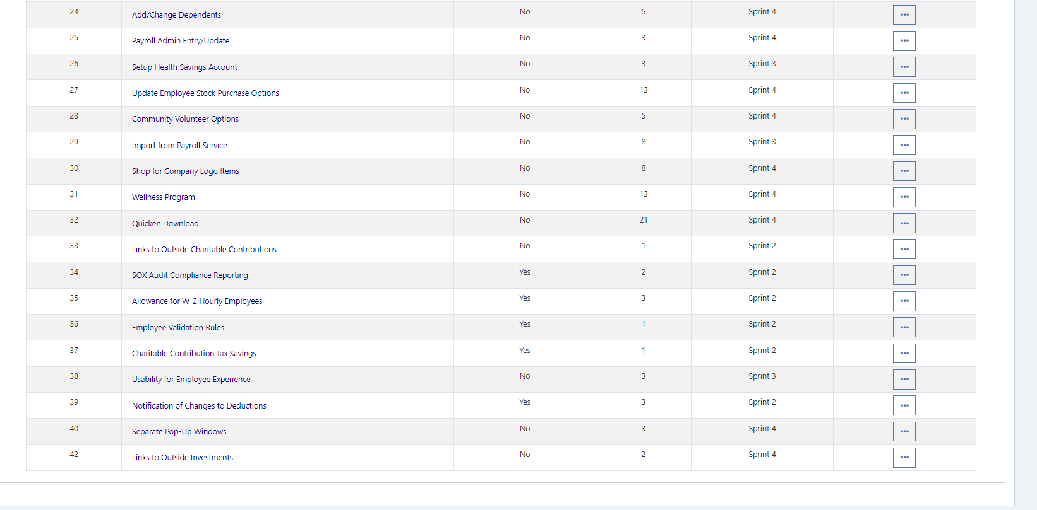

Please explain what you did in grooming the user stories in your Product Backlog and your reasoning for these decisions.

**Answer**

**Removed 2 user stories and put it to sprint 3**

**Scrum Board**

Scrum Board screen shot before sprint 2 has started

**Answer**

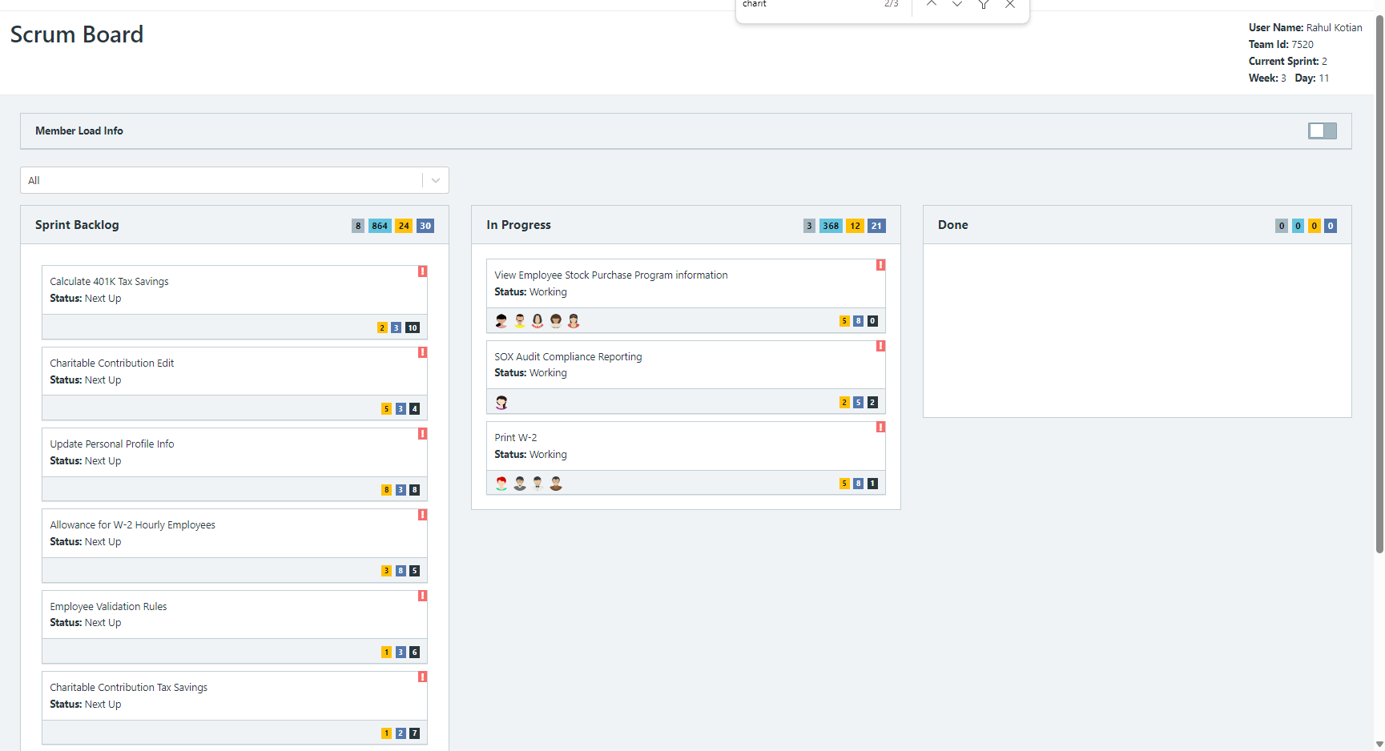

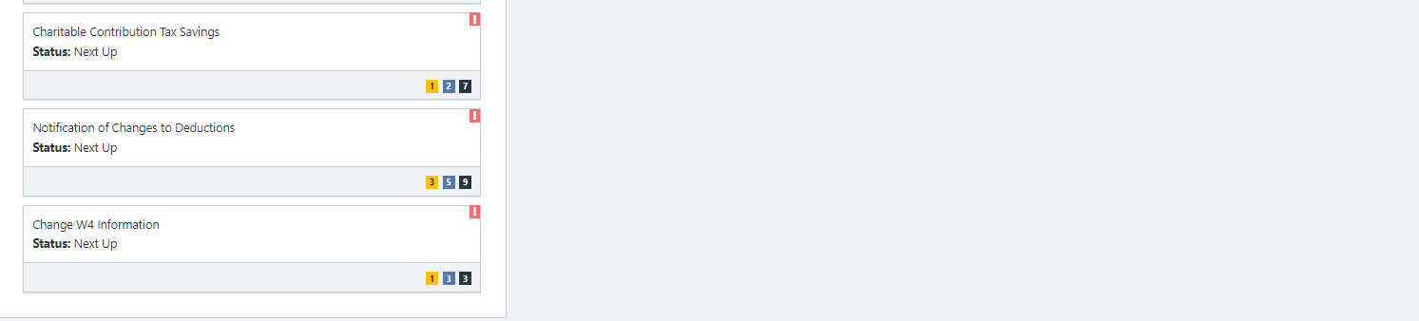

Scrum Board screen shot after 1st week of sprint 2

**Answer**

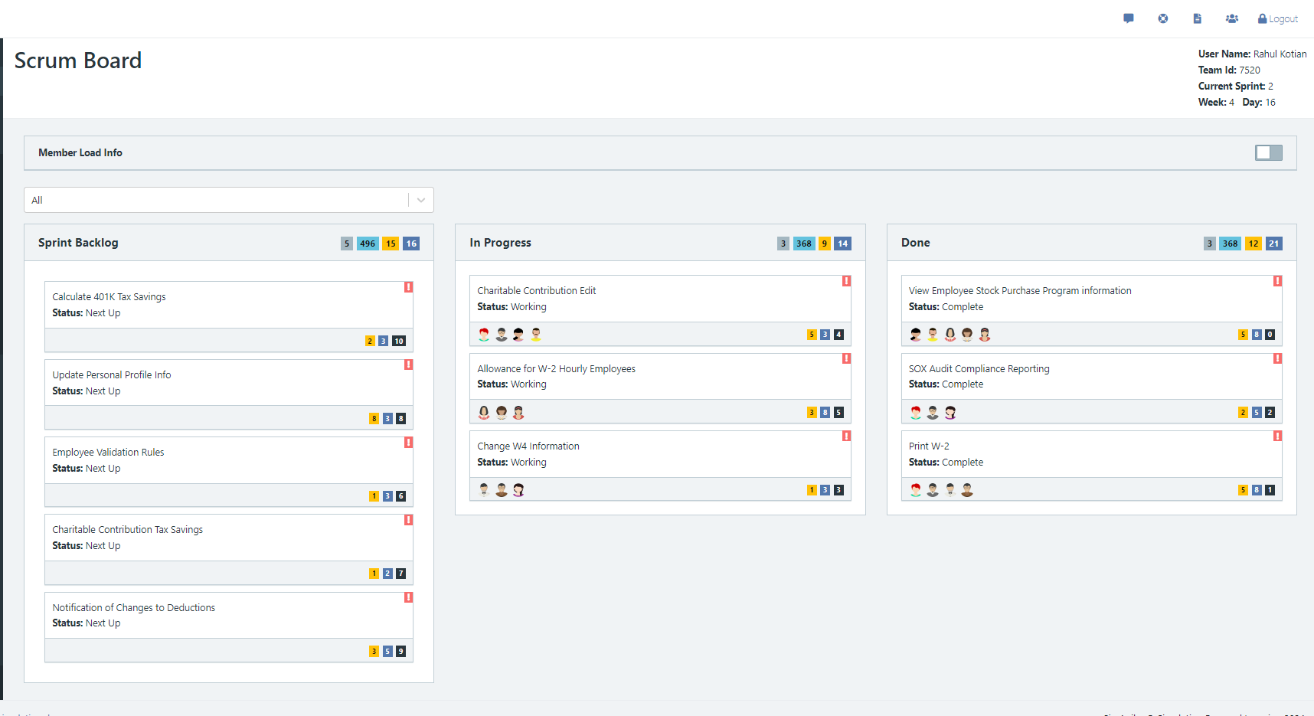

Scrum Board screen shot after 2nd week of sprint 2

**Answer**

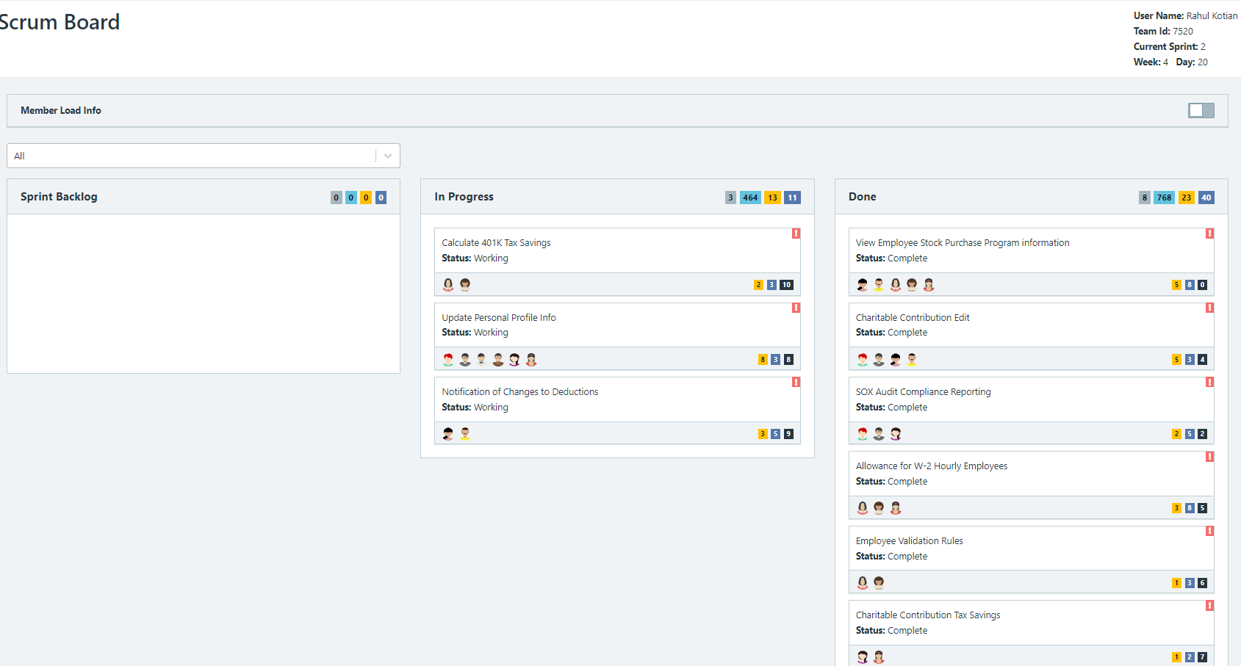

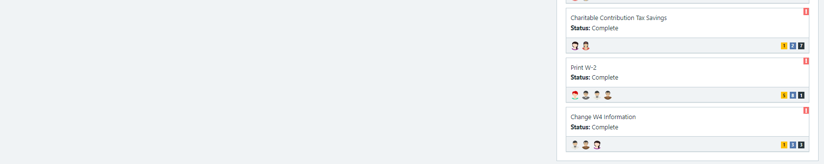

**Calendar**

Paste the screen shot of your calendar for sprint 2

**Answer**

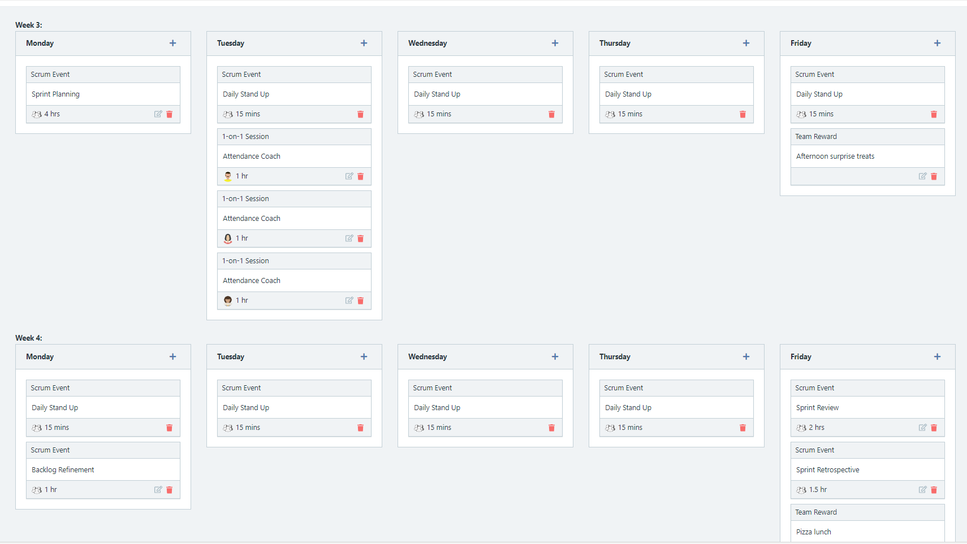

Explain the reason why you have scheduled the meetings listed shown on your calendar (if any)?

**Answer**

**BurnDown**

After competing sprint 2, paste a screen shot of the sprint 2 Burn Down Chart below.

**Answer**

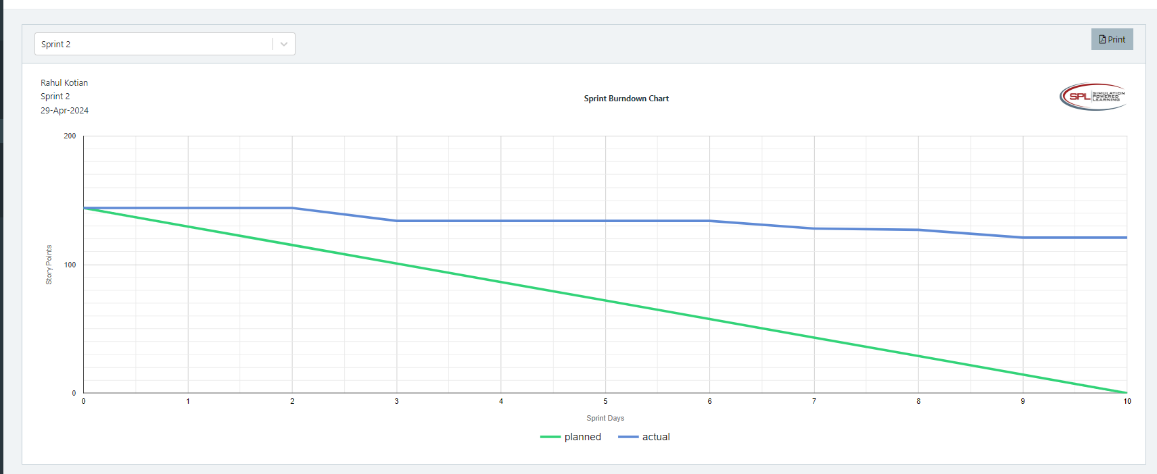

**Velocity Trend**

After competing sprint 2, paste the sprint 2 Velocity Chart below:

**Answer**

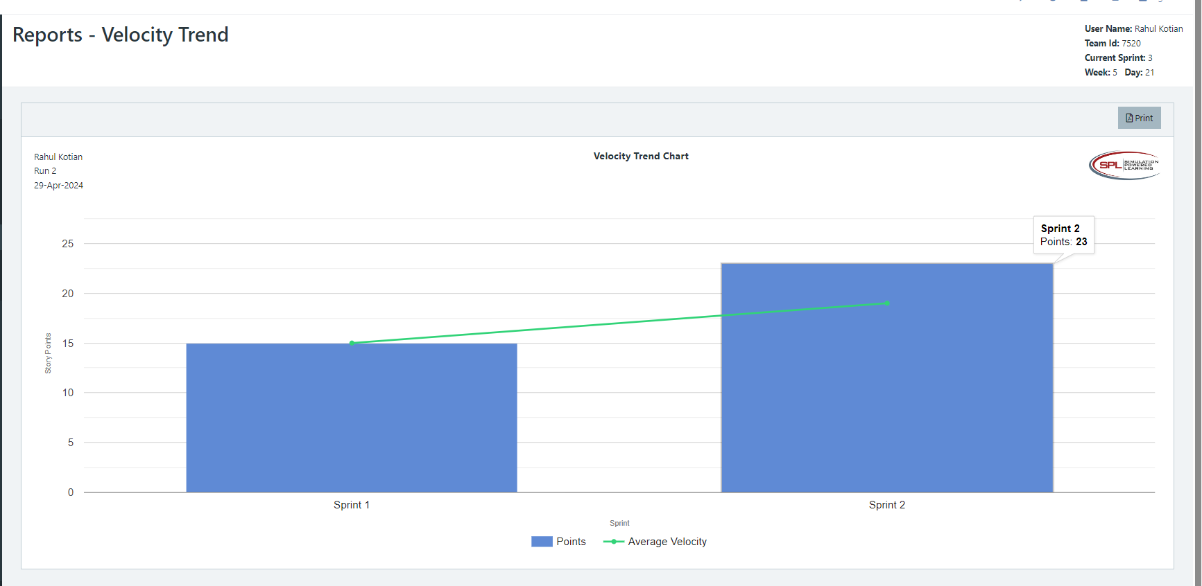

**Retrospective Meeting:**

How did you do in this Sprint?

**Answer**

What problems, if any, did you encounter as you were executing the sprint?

**Answer**

User Story: **SOX Audit Compliance Reporting** has been added to the sprint from the backlog.

User Story: **Allowance for W-2 Hourly Employees** has been added to the sprint from the backlog.

What changes, if any, are you are planning to make in the next sprint?

**Answer**

**Answer following questions based on this Sprint:**

What is the velocity (in story points) for the sprint?

**Answer**

What is the average velocity, minimum velocity, and maximum velocity (in story points) for the project across all sprints that have been completed so far?

**Answer**

Based on the current status of your project, do you believe that you will be able to complete the mandatory (or required) stories in the product backlog within the four sprints?  Explain your answer.

**Answer**

Based on the current status of your project, do you believe that you will be able to complete all stories in the product backlog within the four sprints planned? Explain your answer.

**Answer**

**Sprint 3 - Week 5 and Week 6 (10 points)**

**Product Backlog (one screen shot for sprint 3)**

* Paste the screen shot of your product backlog below.

**Answer**

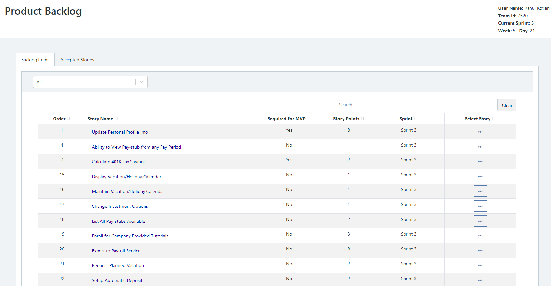

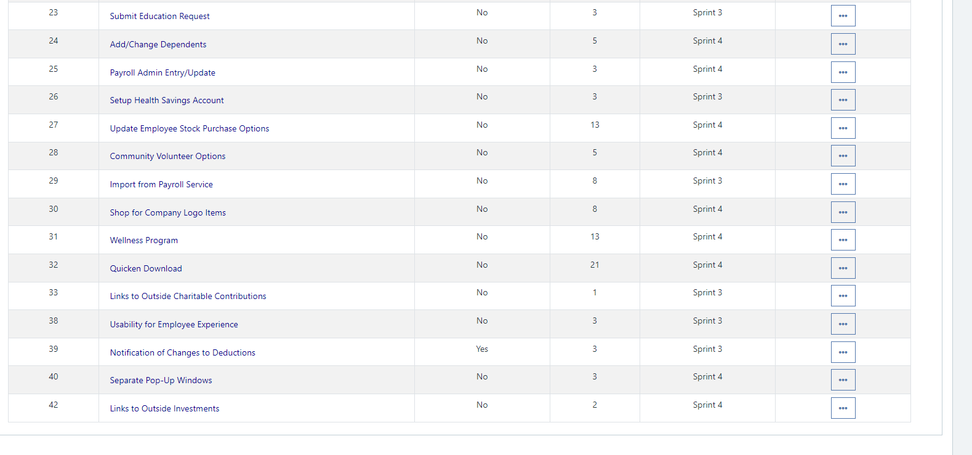

* Please explain what you did in grooming the user stories in your Product Backlog and your reasoning for these decisions.

**Answer**

**Scrum Board**

Scrum Board screen shot before sprint 3 has Started

**Answer**

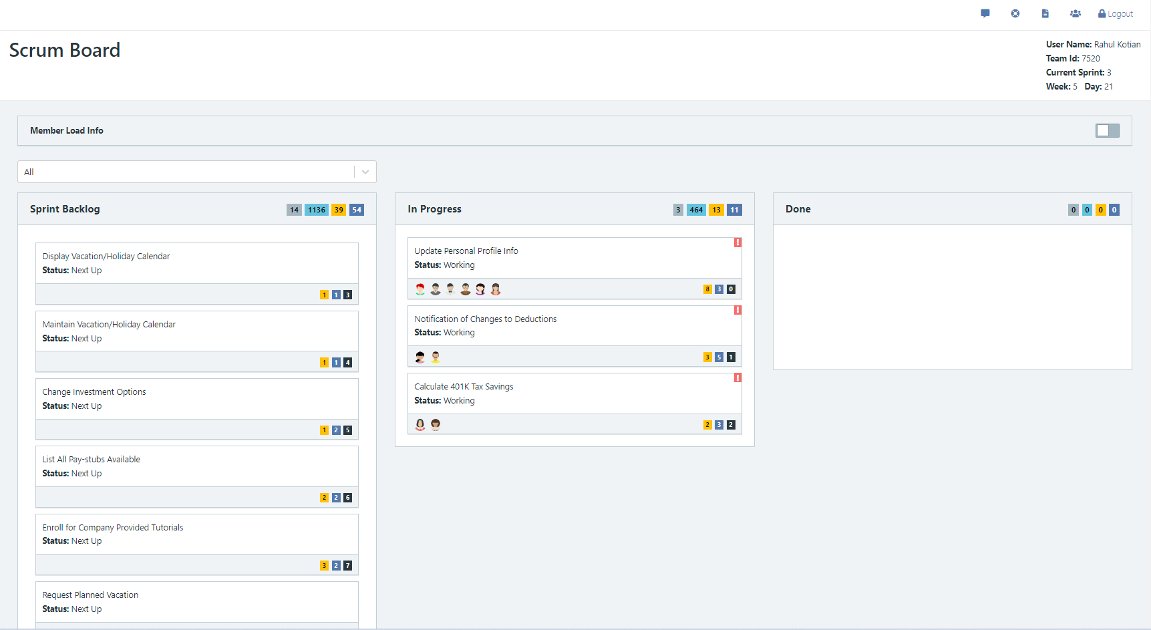

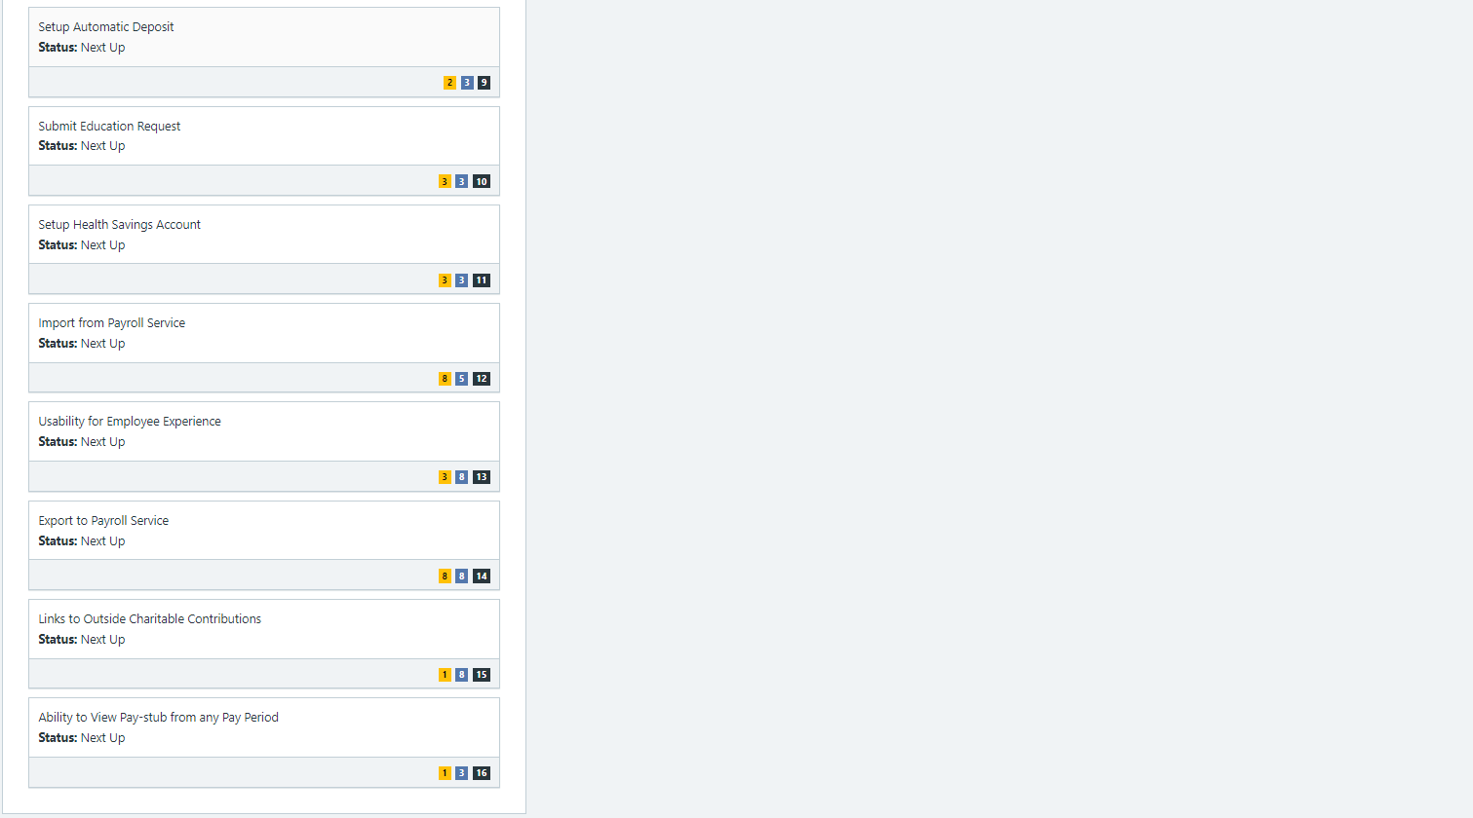

Scrum Board screen shot after 1st week of sprint 3

**Answer**

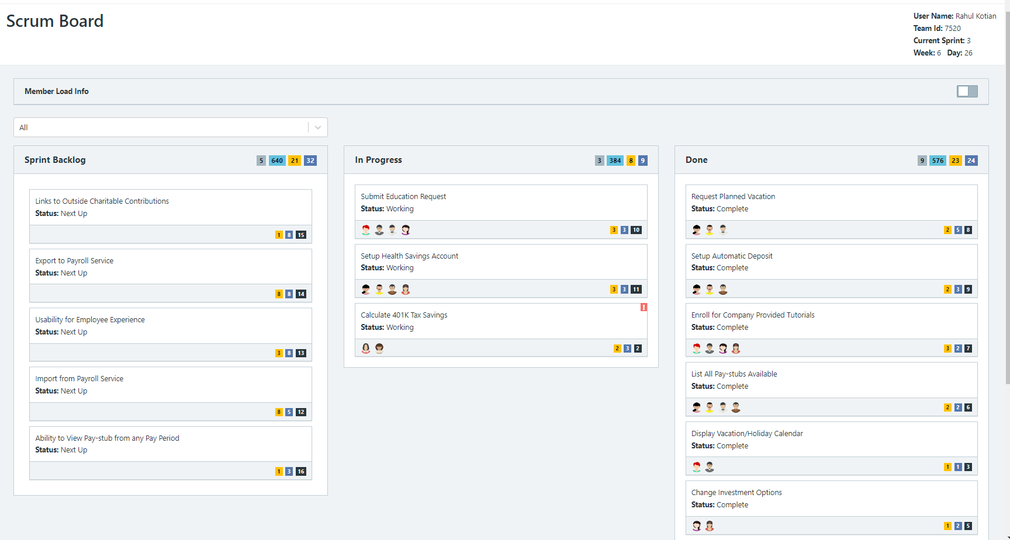

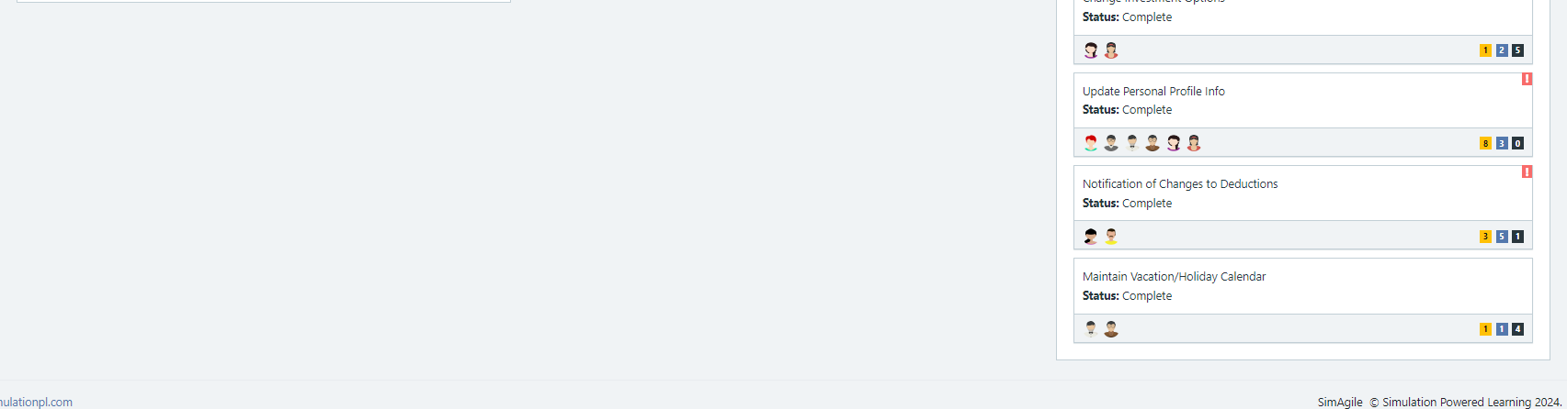

Scrum Board screen shot after 2nd week of sprint 3

**Answer**

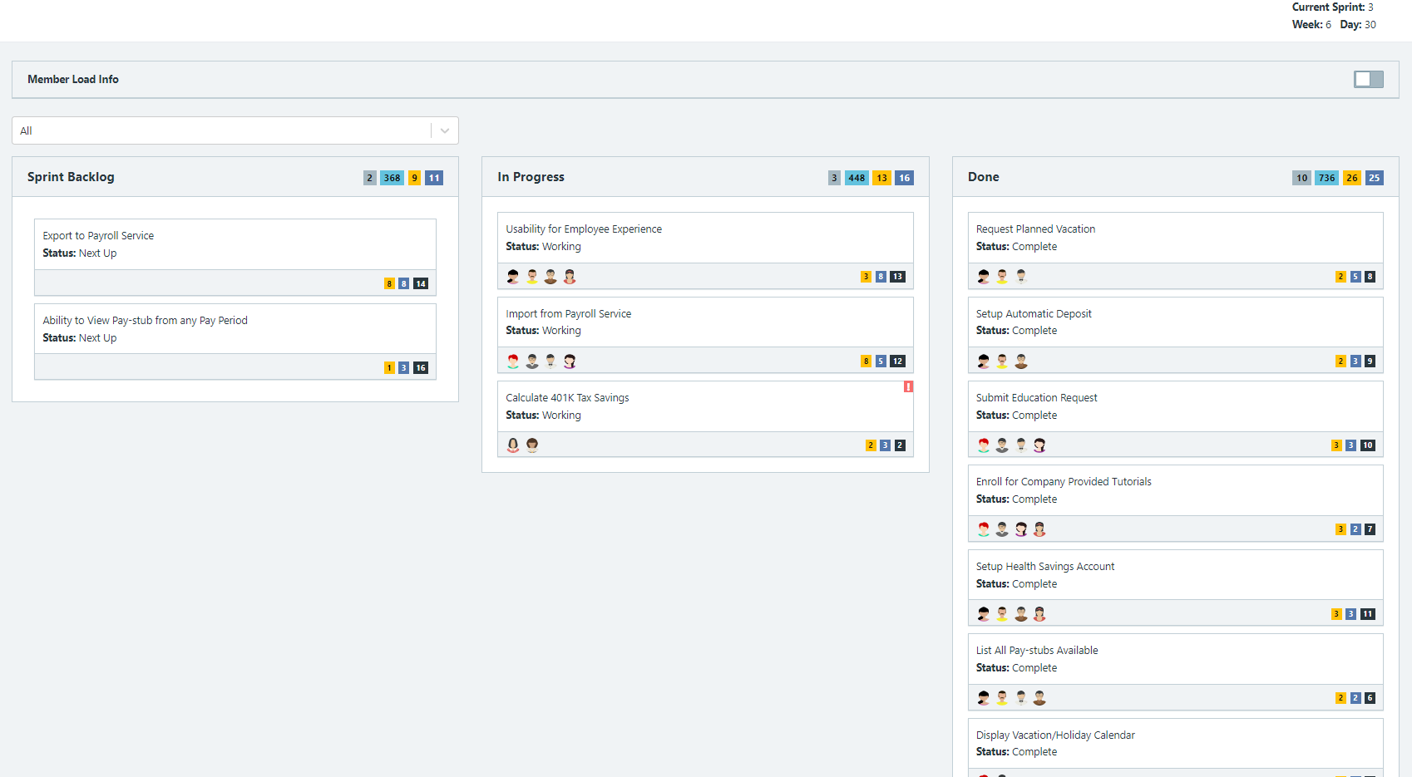

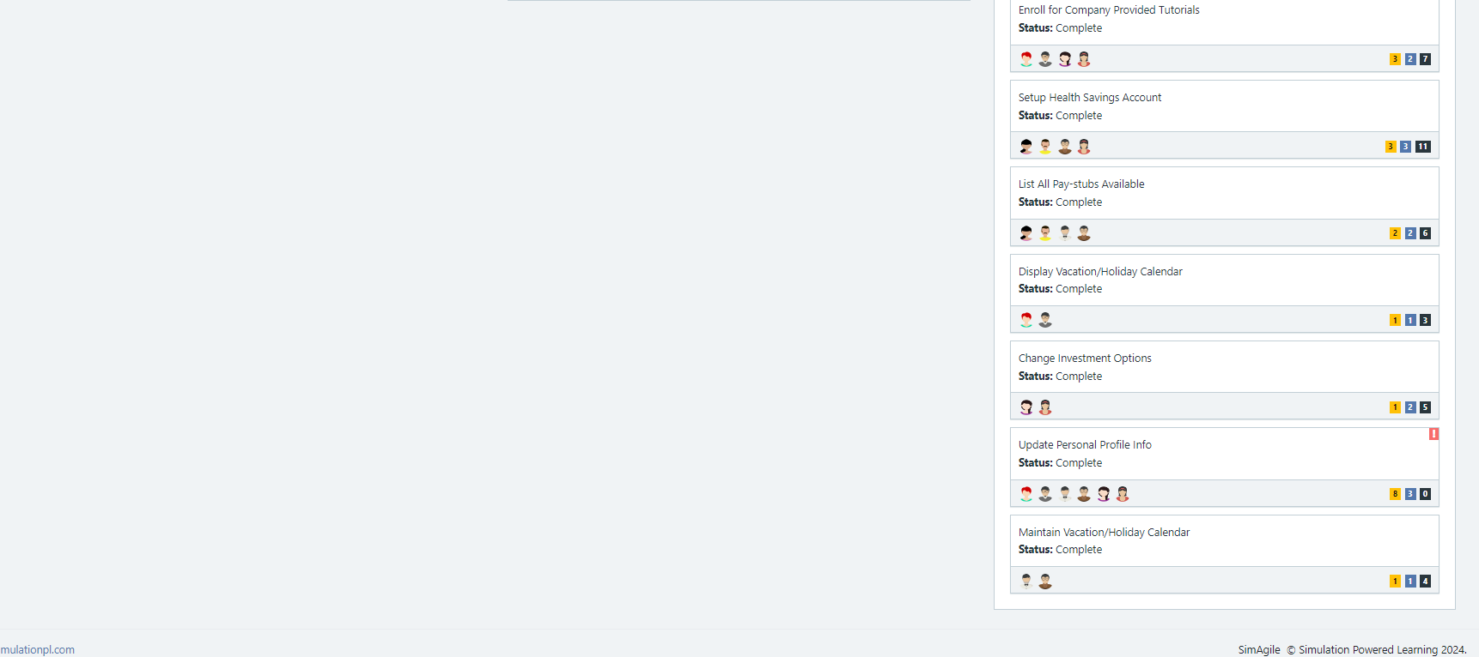

**Calendar**

* Paste the screen shot of your calendar for sprint 3

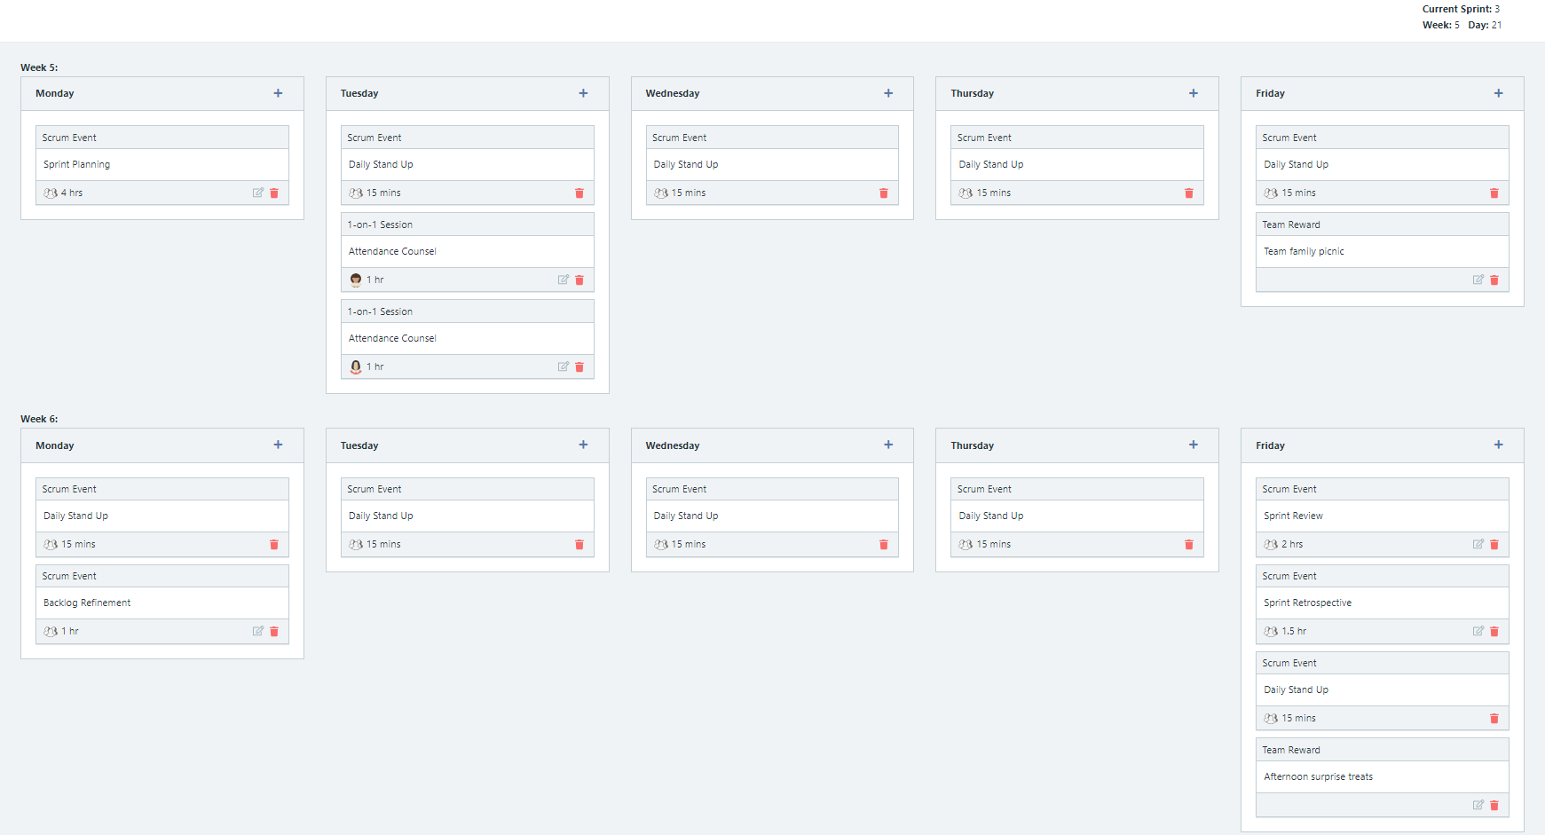

Explain the reason why you have scheduled the meetings listed shown on your calendar (if any)?

**Answer**

**BurnDown**

After competing sprint 3, paste a screen shot of the sprint 3 Burn Down Chart below.

**Answer**

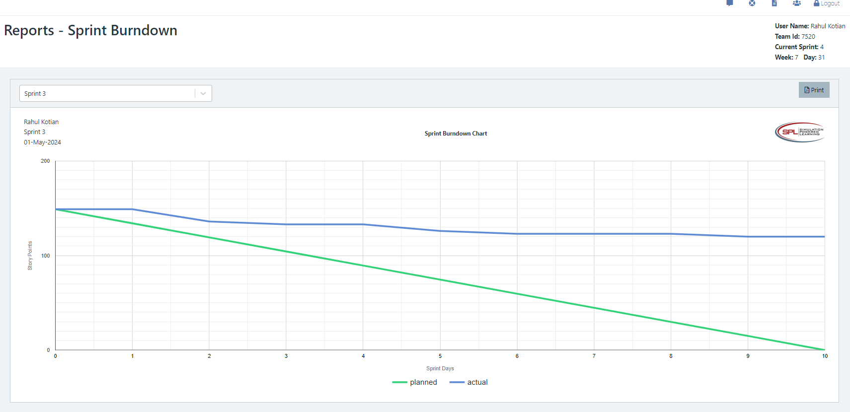

**Velocity Trend**

After competing sprint 3, paste the sprint 3 Velocity Chart below:

**Answer**

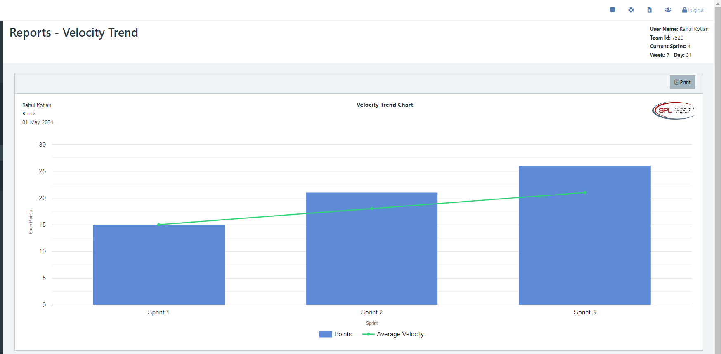

**Retrospective Meeting:**

How did you do in this sprint?

**Answer**

What problems, if any, did you encounter as you were executing the sprint?

**Answer**

What changes, if any, are you are planning to make in the next sprint?

**Answer**

**Answer following questions based on this Sprint:**

What is the velocity (in story points) for the sprint?

**Answer 26**

What is the average velocity, minimum velocity, and maximum velocity (in story points) for the project across all sprints that have been completed so far?

**Answer**

average velocity: 21

minimum velocity: 15

and maximum velocity: 26

Based on the current status of your project, do you believe that you will be able to complete the mandatory (or required) stories in the product backlog within the four sprints?  Explain your answer.

**Answer**

4. Based on the current status of your project, do you believe that you will be able to complete all stories in the product backlog within the four sprints planned? Explain your answer.

**Answer**

**Sprint 4 - Week 7 and Week 8 (10 points)**

**Product Backlog (one screen shot for sprint 4)**

* Paste the screen shot of your Product Backlog below.

**Answer**

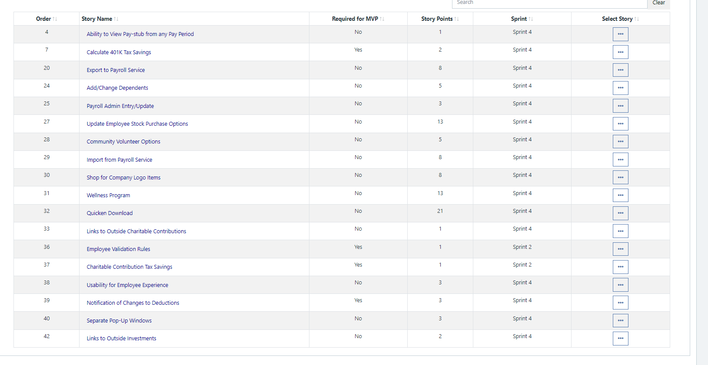

* Please explain what you did in grooming the user stories in your Product Backlog and your reasoning for these decisions.

**Answer**

**Scrum Board**

Scrum Board screen shot before sprint 4 has started

**Answer**

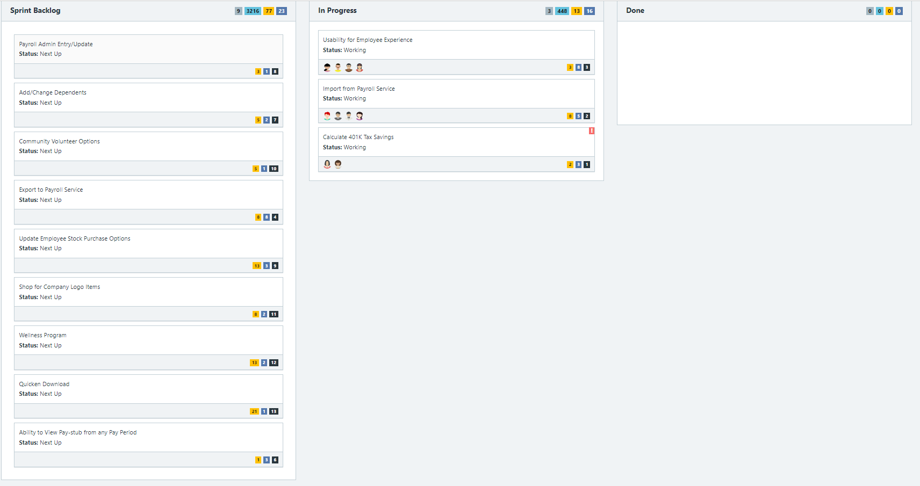

Scrum Board screen shot after 1st week of sprint 4

**Answer**

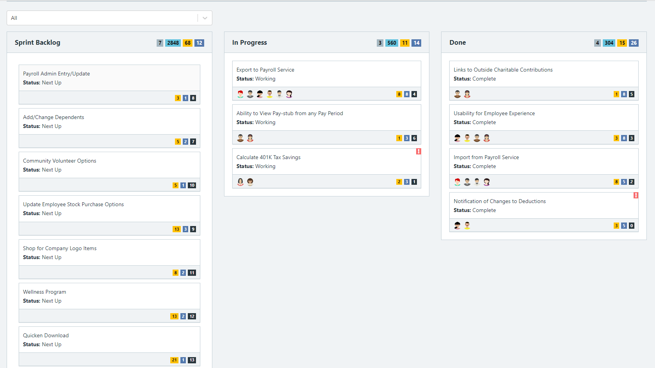

Scrum Board screen shot after 2nd week of Sprint 4

**Answer**

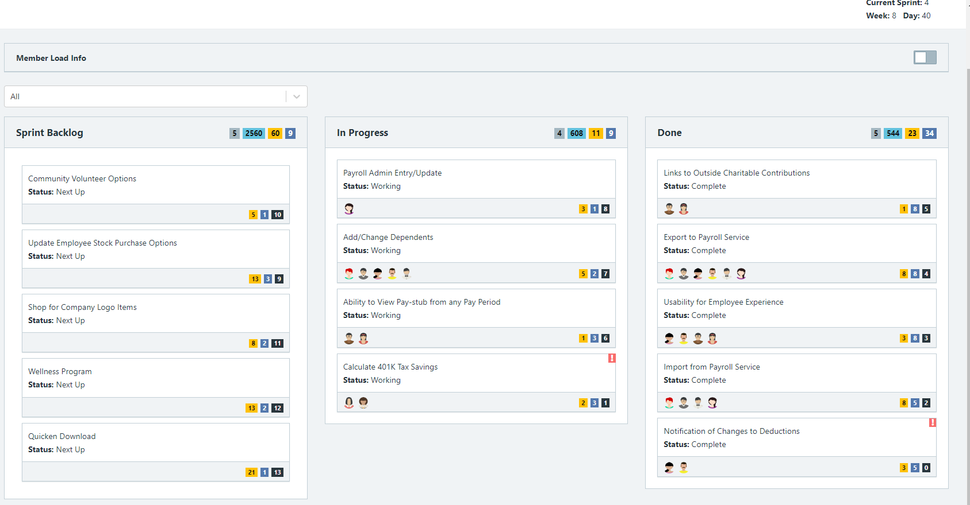

**Calendar**

Paste the screen shot of your Calendar for Sprint 4

**Answer**

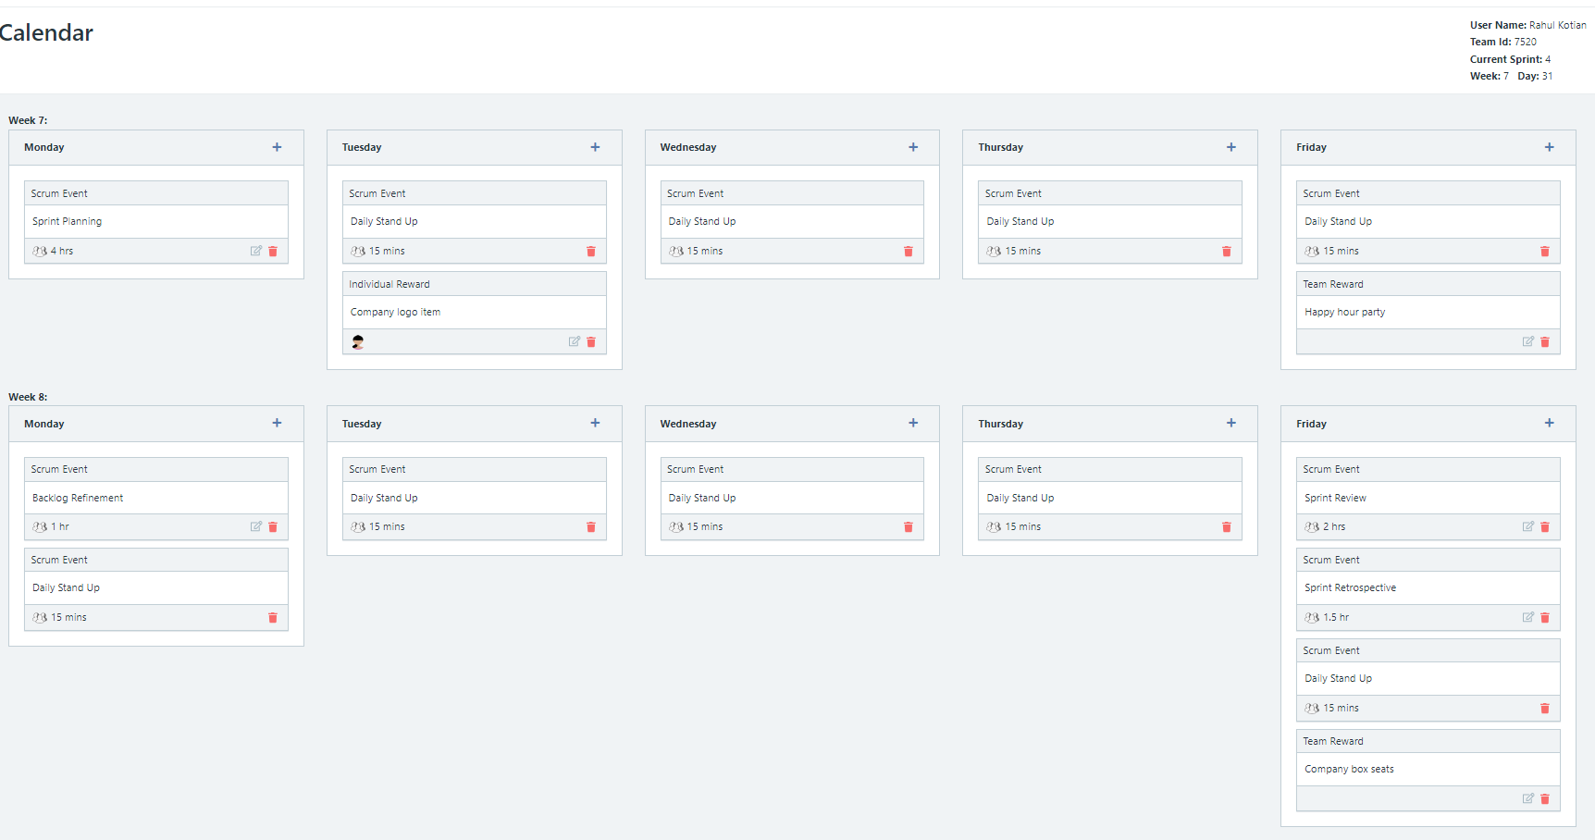

Explain the reason why you have scheduled the meetings listed shown on your calendar (if any)?

**Answer**

**Retrospective Meeting:**

How did you do in this sprint?

**Answer**

What problems, if any, did you encounter as you were executing the sprint?

**Answer**

What changes, if any, are you are planning to make in the next sprint?

**Answer**

**Answer following questions based on this Sprint:**

What is the velocity (in story points) for the sprint?

**Answer 30 points**

What is the average velocity, minimum velocity, and maximum velocity (in story points) for the project across all sprints that have been completed so far?

**Answer**

average velocity: 22

, minimum velocity: 9,

and maximum velocity: 30

Did you deliver all required functionality needed for the MVP?  Explain your answer.

**Answer No**

Did you deliver all the user stories in the product backlog? What were the three most significant items that effected your team’s performance?

**Answer No**

**SimAgile Retrospective (20 points)**

The next three questions pertain to your thoughts about the performance of the BAAT project team across all four sprints after the project has completed.

1. How many story points did your BAAT project team deliver in your best execution of the simulation?

**Run 1 : 88 story points**

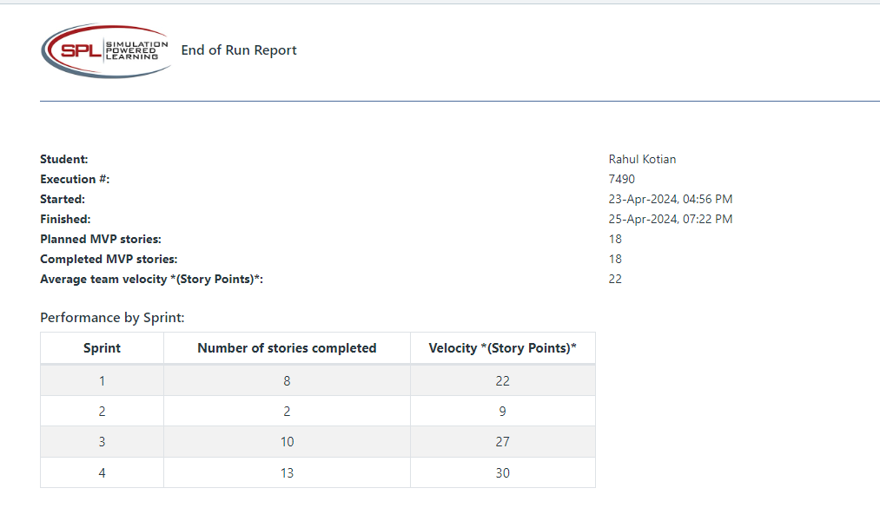

Run 2: 85 story points

1. Describe three things that positively impacted the performance of the BAAT project team.

* Training
* 1-on –1
* Team rewards to boost morale

(Rahul)

1. Describe three things that negatively impacted the performance of the BAAT project team.

* Individuals Missing standups
* Team collaboration wasn’t the best
* New requirements identified and added to the backlog.

(Rahul)

The final two questions pertain to your overall thoughts about the Agile Project Management. It is okay to use ChatGPT (or similar) to help answer the next two questions. If you use ChatGPT, include all of the prompts you used to generate the response and clearly cite the fact that you used ChatGPT to generate the response.

1. List and describe all the different ways the Scrum process incorporates the concept of feedback. Why is feedback important to project success? (Note: Your response is limited to 500 words or less)

(Rahul)

1. How will you ensure teams you work with in the future are open to receiving feedback and excel at giving feedback? (Note: Your response is limited to 500 words or less)

(Rahul)